CYSE 304
HW 2

- The circuit shown in Fig. 1 is CMOS inverter. If the input is bit 1 show on the circuit, how can you get bit 0 at the output.

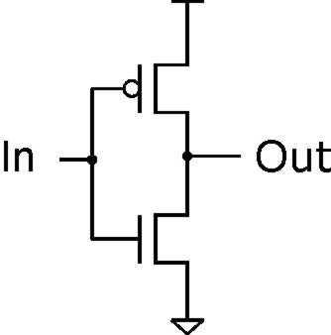
Fig. 1

- For the CMOS circuit shown in Fig. 2 determine:
  - The kind of the Gate.
  - If the inputs A = 1, B = 1, what is the output C? Show on the circuit how you got the output.

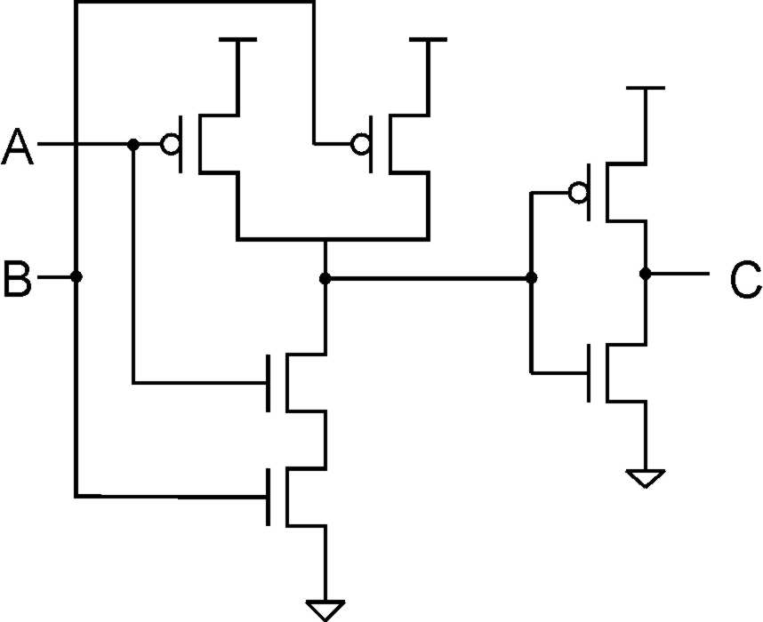
Fig. 2

- The input and output logic levels for CMOS are given in Fig. 3.
  - Define the noise margin.
  - Determine the values of the low and high noise margins V_{NL} and V_{NH}?
  - If the corresponding values of TTL are V_{NL} = V_{NH} = 0.4 V, which values are better? Why?

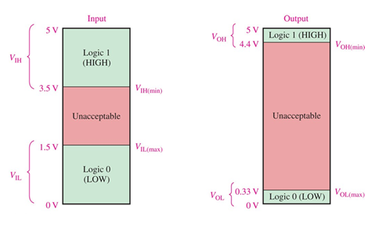
Fig. 3

- A certain gate draws 2.4 µA when its output is HIGH and 4.8 µA when its output is LOW.
What is the average power dissipation if Vcc is 5V and the gate is operated on a 50% duty cycle?

